The Snake Boyz
MIDI to DMX Machine (Snake Box) project proposal
CS 121
3/27/17
Sage Hahn

Table Of Contents
Introduction – 3
Definition Acronyms and Abbreviations – 4
Project Detail 5-12
Budget 13
Project Plan 14
Target Market 15
References 16

Introduction
This project is designed to implement the raspberry PI as a MIDI to DMX converter. Where MIDI is a technical standard, allowing communication between audio devices and computers most generally, and DMX representing a similar standard used in lighting devices. The basic goal of the project is to provide an interface for a player of an electric keyboard (with MIDI out) the ability in real time enact lighting changes in lights capable of working with the DMX protocol. While a number of higher end lighting boards allow some interaction with sound, and a number of also interesting and similar technology exists, the primary focus of the project will be in programming the interaction to accurately represent visually the musical component.
This project will make use of some already established technologies and programming libraries to ease the facilitation between two complicated protocols. In addition, it should be noted that other hardware will be used in the core of the machine, notably a MIDI to USB converter and a USB to DMX converter, as the electrical engineering of these products, while possible, is beyond the scope of the project. Lastly, a significant goal of the project will be to ensure a wide range of functionality with a range of different MIDI generating sound devices and lighting instruments on either end.

Definitions Acronyms and Abbreviations
MIDI: A technical standard and protocol which dictates the communication between a large number of different electric instruments, computers and specifically designed controllers.

DMX512: Digital Multiplex or DMX512, is the technical standard used in the operation and control of primarily stage lighting and associated effects. It is commonly used in linking lighting controllers with lighting instruments, and as a connection between different lighting instruments.

XLR: A cable often used in sound environments that transmits microphone level signal, and is used sometimes as keyboard output.

¼ Inch Instrument Cable: A cable often used by instruments such as electric guitars or keyboards to output line level siginal.

LED: In the context of lighting fixtures, LED's are lower powered lights, sometimes capable of receiving DMX512 information

OLA: Open Lighting Architecture, A framework for lighting control information, that supports a range of different protocols for connecting lights and computers.

Project Detail
This project at its most basic level, works around the following pieces of technology, and follows the rough signal flow as described and shown below.

Each Individual part of the signal flow, and it's role/how it connects to the next piece:

-Some sort of keyboard capable of generating a MIDI signal, but in the most basic implementation of the project, not reliant on generating sound through it's MIDI output. The idea here, is that a keyboard of synthesizer of some sort capable of generating its normal array of sounds and when used live sends it's audio output either through it's ¼inch instrument cable or an XLR out, is also capable of generating an additional MIDI signal. By capitalizing on this unused capability, a MIDI cable will be run from the device to the MIDI to USB converter. The keyboard's used in actual testing will be the microKORG and the novation ultraNOVA, both synthesizers capable of generating MIDI out.
https://global.novationmusic.com/synths/ultranova#
http://www.korg.com/us/products/synthesizers/microkorg/

-The MIDI to USB converted used in this project will be the Roland UM-ONE USB MIDI interface, while this product contains functional proprietary drivers they will be ignored in the scope of this project, and they are not specifically designed for working with Linux. This device will be responsible for converting the incoming MIDI signal into serial information which will be fed into the Raspberry Pi, and interpreted and received primarily by the pygame midi library (and dependent libraries and software). This device was chosen for cost and ease of use, in theory a comparable fully open source device could be manufactured with proper knowledge and supplies.
https://www.roland.com/us/products/um-one/

-Program used to interrupt the MIDI data received, this program will make use of the pygamemidi python library in order to convert the received MIDI input into a usable format. Specifically, MIDI data is received eventually (after being run through the provided function) in the form of a 3-tuple of numbers. The library, also via the protocols and other libraries it makes use of, also facilitate easily creating a connection between the MIDI device and the computer. After the connection is created, the program is receiving a constant stream of MIDI information, a significant chunk of this just clock sends with little useful information. This stream will also contain more useful information such as what type of actions was preformed (key press or key released being the most useful here) how hard it was pressed, and other information such as if the pitch wheel is used, ect... In it's most limited form, this project will only work with key press,release and intensity values, though other information like pitch or mod wheel could potentially be incorporated.

-An intermediary program which will analyze the data received above, and convert it into specific commands to be sent out over DMX and eventually change the lights. This intermediary logic is where the bulk of the actual coding and new work will be done. The goal around this area is to implement in interesting, creative and unique ways the actual interaction between MIDI and DMX. In it's most limited form this would take the role of simply sending DMX triggers based on note pressed, and some basic functionally around fading the light when key released and dealing with chords (multiple keys pressed at the same time). More specific plans for how this will be enacted, and ideas for improvements and additional options on this basic framework will be presented in its own section below, as to not interfere too much with the discussion surrounding the signal flow.

-The program responsible for sending DMX information out from the raspberry PI to the USB to DMX converter in a form that it can recognize and then pass along accurately. This will make use of free and open software called OLA (Open Lighting Architecture), which provides a python interface for sending DMX signal. OLA supports a number of different protocols for connections with USB to DMX devices, I will make use in this case of the

-USB to DMX connection, I will be using the ultaDMX micro, a DMX interface capable of receiving USB 2.0 input and sending a single DMX512 output. This device was chosen for its cost, and it likelihood of ease of use with a raspberry PI system (based on research). This device will be responsible for taking in specifically designed input/commands from the PI via USB connection, and converting to a DMX512 connection that will be sent out in order to control various lighting fixtures.

-The lighting fixtures, there a large number of hypothetical stage lighting fixtures which can be controlled easily with a DMX512 signal, these are most often digital lights or small LED fixtures. Specifically in the scope of this project, larger more complicated moving lights which receive large amounts of DMX information will be excluded, in favor or working with relatively simpler LED's. In it's most basic implementation, the program will be designed to work specifically with LED's set to a setting (this varies in name based on the model and type of device) which receives 3 DMX channels, one for red, one for blue and one for green, with values ranging from (typically) 0-255. The most basic program will be designed to make used of a number of these lights set to sequential addresses (Light 1 on 1, light 2 on 4, light 3 on 7). Again, the actual rough design for the program is explained in more detail below. Potential improvements to the project beyond the basics include designing in compatibility with a variety of different types of lighting fixtures.
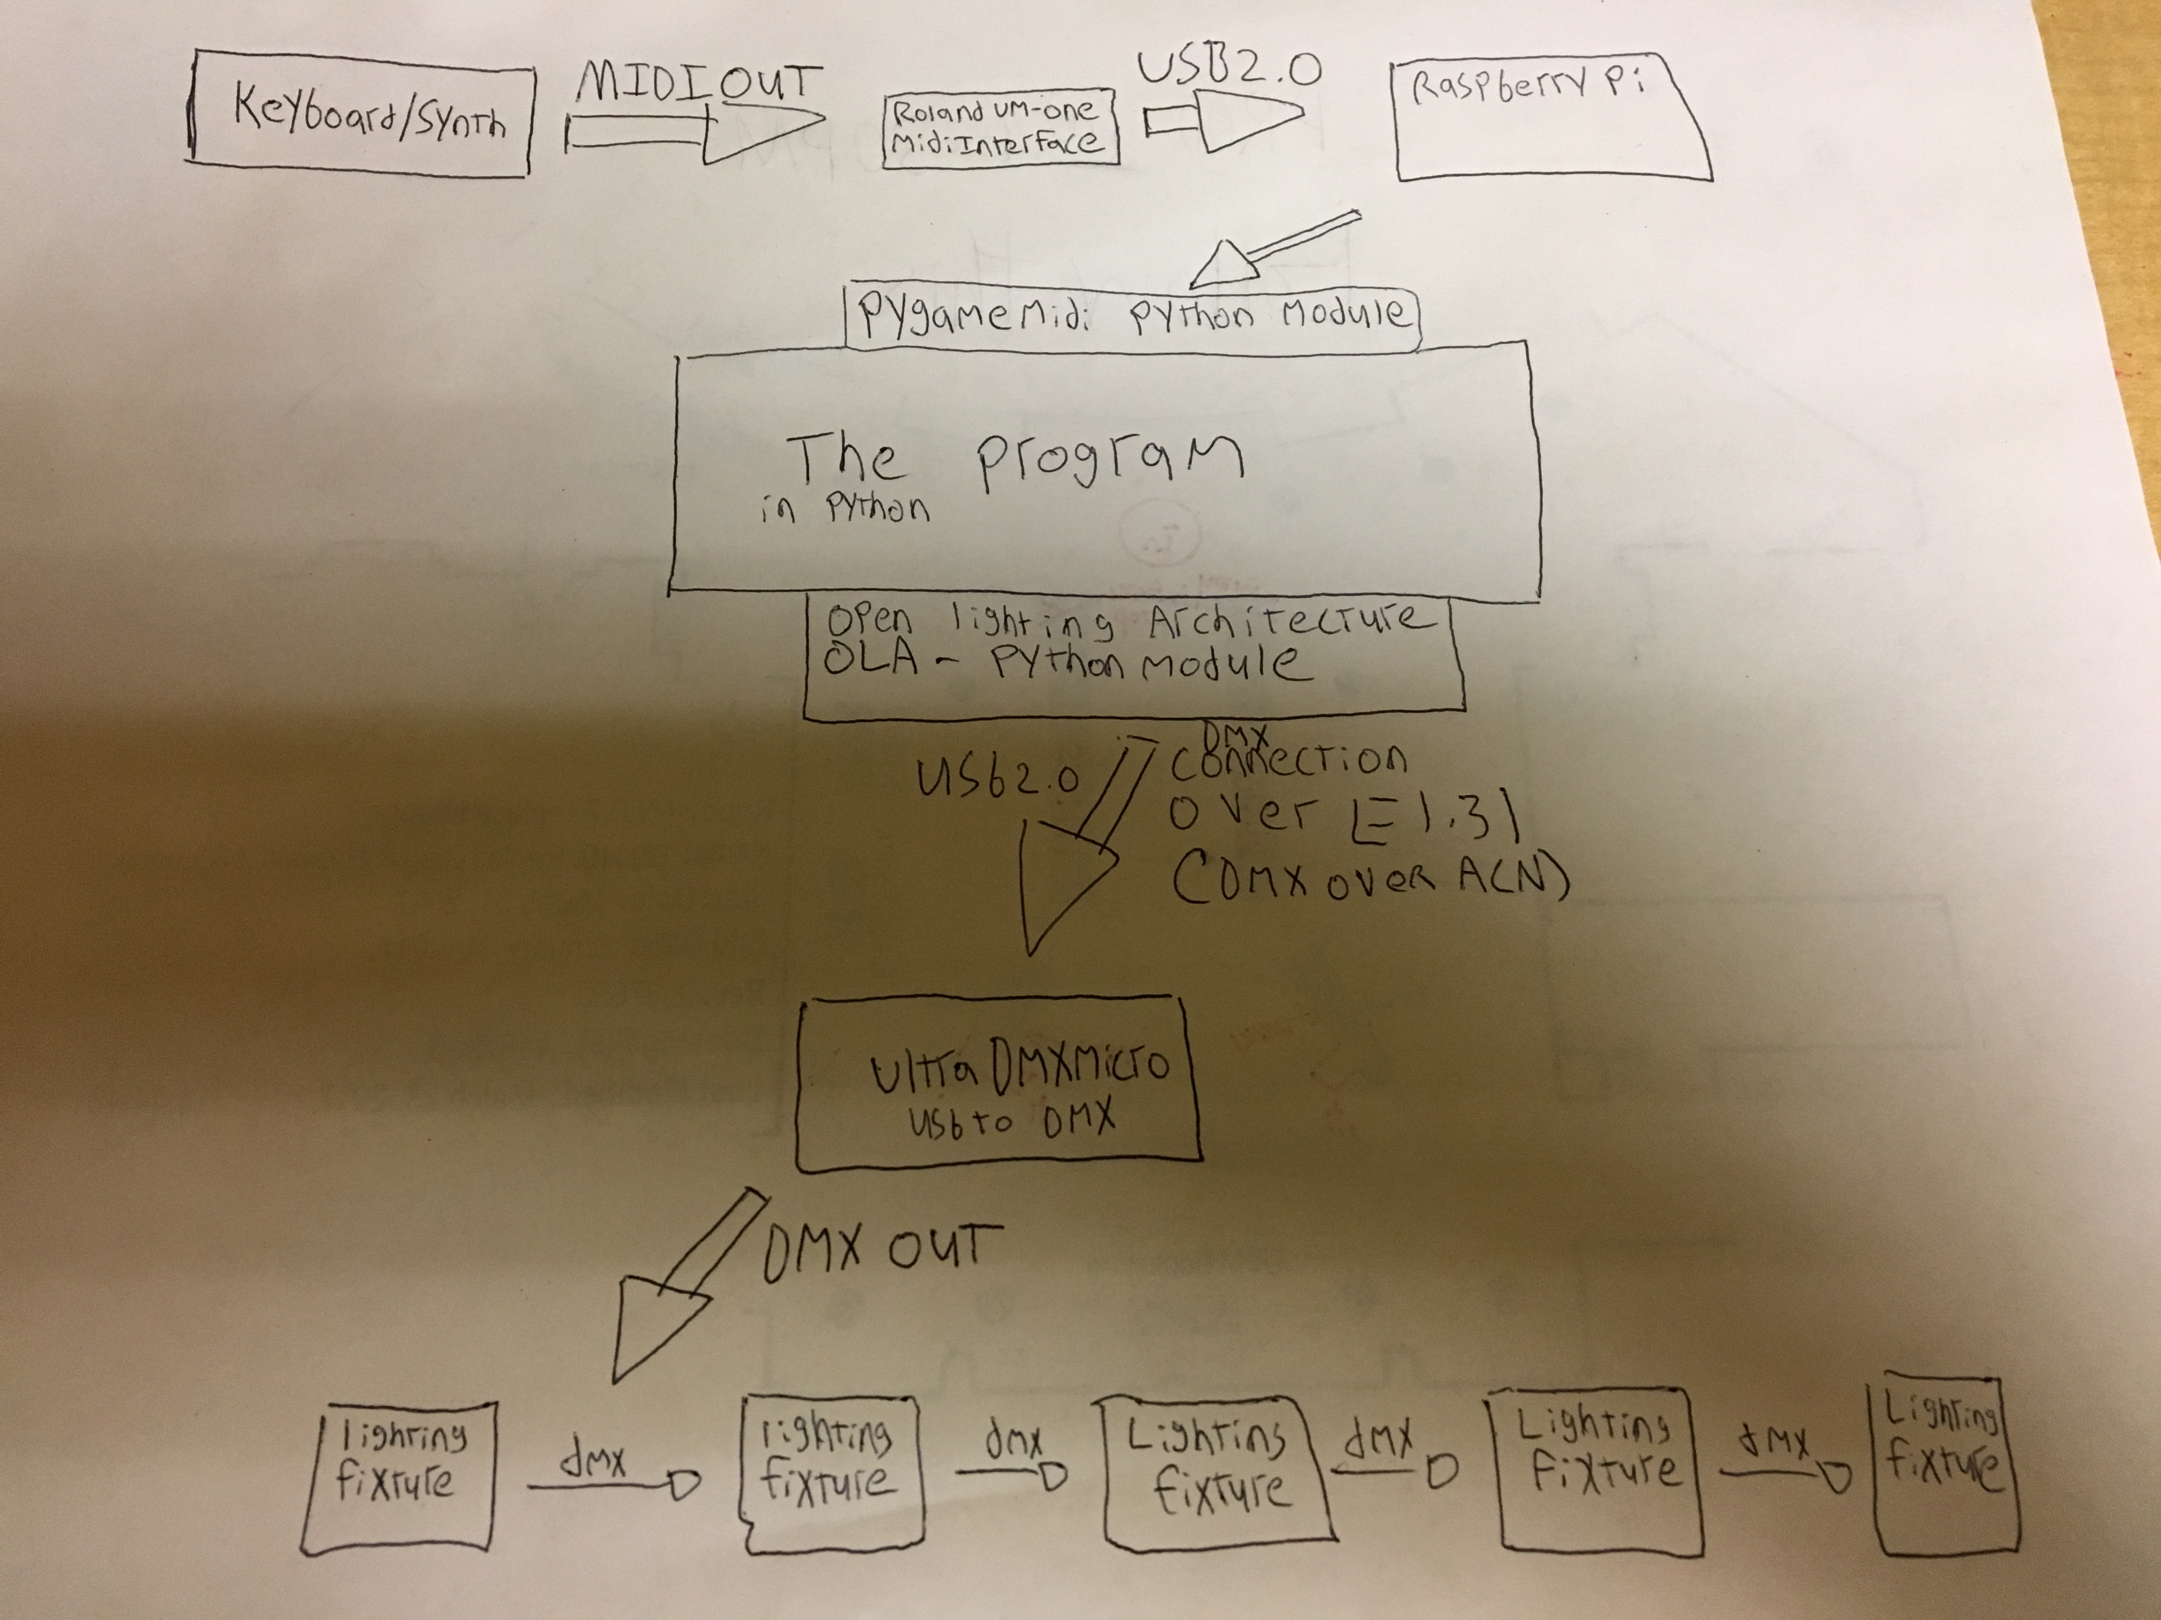
THE SIGINAL FLOW:

The program in more detail:

In it's most basic functionality the program will work by taking in midi notes, and for each key pressed will signal a series of events, consider an example below:

-A key is pressed with the note value 24 (corresponding to positions on the key board), and a velocity of 60 (0-127 accepted). Their exists an array containing information on which keys are active, the associated position for 24, active[24] will be set to the value of the next open light. Open lights are stored in a sorted queue, and since this is the first to be pressed, active[24] will be set to the value 1. Next, changes to another array containing channel values for the lights will be made. Since it's address value is set to 1, channels 1,2,3 will be set to certain colors. The color is determined by velocity and the key pressed note value. In this case, (24 % 12) = 0, which means the note is a C, and the color value assigned to C is red. So channel 1 will be set to 60 (the velocity) times 2, and channel 2-3 will remain at 0, as the color red is associated only with the first channel.

-At this point the following information is stored:

active[0-23] = 0
active[24] = 1
active[25+] = 0

channel[1] = 120
channel[2+] = 0

-After the channel values are set, a call is made to send DMX information. The send DMX command reads in the channel information and sends it out as a DMX command.

-Consider that while the first key is pressed a second is pressed, note 26, with a velocity of 100, active[26] will be set to 2 and channels 4,5 and 6 will be set to the color associated with the note D (26 % 2), which is set by channel[4] = velocity times 1, channel[5] times 1, which is a mix of red and green, yellow. Then the send DMX is called again, and that color is effectively displayed on the second light.

-Once a key is released, lets say 24, (26 is still being held), channel[1-3] are set to 0, the value of active[24] is put back on the heap, and then active[24] is to 0. The stack now looks like (1,3,4,5, ect...), and the send DMX command is called, turning off the first light. At this point, if the other key is released, that light will be turned off, or if another is pressed it will fill in at the first slot.

In essence the bare bones of the program ensures that for every note held, a light with it's associated note is lit for the duration The end effect, is to provide a real time trigger for notes being played, and to allow and even encourage chords (multiple notes played at once). The psuedocode above describes how this process is implemented roughly.

Ideas for extra features:
While the above constitutes a bare bones functional version of the program, time willing, there will be a number of extra features. Some are listed below.

-Making use of the mod wheel data, a feature most midi keyboard are capable of sending. The wheel ranges between 0-127, in the MIDI data it sends. One potential feature is to have whatever lights are on at whatever values, strobe (turn on an off) the rate dependent on what the mod wheel is set to. For example, if turned fulled up (127) and a chord was held down, the lights would flash as rapidly as possible.

-An alternate version for the program where the stack used to address key's pressed to lights is unordered. What this would accomplish, is that instead of pressing one note over and over, and just having the same one light turn on, each press would trigger a new different light, producing a more chaotic effect. A number of small tweaks could be made to the stack, or even replacing it with a queue, or adding in actual random function to accentuate this effect.

-Making use of the pitch wheel, a feature which bends notes either up or down. The MIDI data sent by the pitch wheel is difficult to work with, but in theory, it would be very interesting if the pitch wheel could also 'bend' the color/s of whatever lights are active.

-Making use of some large library of music theory, where beyond the note being played, the actual chord was analyzed. For example if a C Major chord was played, a specific hard coded lighting response would occur. Or even in a more limited sense, everything would remain as above except specific chords could be 'rewarded' with special effects. I don't have any ideas what these would be. An educational program could be implemented here as well, something like practicing soloing or scales, and if right notes are hit the lights are green, and if it is wrong then red.

-Making use of fade outs and fade ins. For example a mode could be added where after a note is released, instead of instantly turning off it could fade out at a predefined rate. In addition, a feature could be added that slowly increases the intensity of notes/chords the longer they are held.
-Making use of different octaves, octaves in music being the groupings of the 12 chromatic notes. For example, the first note played could be established as the 'middle note', or even the program could begin with a calibrating mode where the user plays their lowest note and their highest note they wish to use. Then instead of (or perhaps in addition to) the colors triggered by keys could take into account the octave. For example, notes at the lower end triggering darker colors, and then switching to the higher end coming closer towards white and lighter colors (this might be difficult with LED's).

-Multiple effects for a single key, mapped to different lights. For example, their could be two or more lights assigned for each key pressed, with one acting normal and the other say on a strobe setting based on the position of the mod wheel, or set to just flash white once after the initial key press. The general idea here being, that with enough lights available, a number of effects could be used all at once.

Budget

Additional Supplies Purchased:
-ultraDMXMicro USB to DMX converter 70$
-Roland UM-ONE MIDI interface 40$
-Powered USB Hub 8$

Supplies Already Owned or Available:
-Raspberry Pi 3 Model B 40$
-MIDI generating keyboard or synthesizer (Variable price)
-DMX receiving LED fixture (Variable Price)

Itemized Labor:
-6 hours of research and proposal writing at 6.75$ an hour (outsourced to India)
-5 hours of working with hardware at 20$ an hour
-20 hours of programming 22.7$ an hour
-6 hours of Quality Assurance and testing at 15$ an hour
-5 hours of paid lunch and other billed time not spent working 20$ an hour

Assuming the above, and that the supplies already owned or available don't contribute to the cost, the overall project cost is 118$ in additional supplies and 784.5$ in labor. Note the cost of labor fluctuates greatly with the weather as all employee's under the Snake Boyz LLC are highly temperamental – ESPECIALLY in regards to the weather.

Project Plan

-Order and test all of the additional supplies – Completed 3/31

-Ensure some level of MIDI to DMX connection via Python on the test laptop running Ubuntu – Completed 3/31

-Ensure the DMX commands and MIDI are sent and received in real time (no lag) – Completed 4/3

-Test a working build of the program (with base line features) on the laptop by 4/7

-Prepare and optimize in any way possible the Raspberry PI, with the prerequisite plugins and software by 4/14

-Test a working build of the program on the Raspberry PI by 4/17

-Ensure the latest working build of the program is functional and ready by 4/27

-Add additional functionality and compatibility support on the program end – Continuously

Target Market
The MIDI to DMX machine's marketability is self evident in it's sleek “thrown together” aesthetic, and speaks volumes for itself. Regardless, I shall attempt to illuminate the virtues of this project in the context of the global open market. The ideal target audience for this project is the musician, or band, looking or rather demanding interesting lighting solutions. The MIDI to DMX machine or Snake Box, for short, allows these budding performers the affordable ability to outshine their competition and step their live performance to the next level. The Snake Box is designed with the musician, and more importantly, the music in mind. Additional interested markets, beyond the touring musician, are the lighting designers. The Snake Box offers these designers an interesting new customizable tool in bringing their venue to life and color in a new exciting way.
The Snake Box presents itself as either a tool, a small piece in a larger lighting design, or a full fledged lighting solution. With a number of different customized options, the end user can take full advantage of the previously unused MIDI out signal and “turn on the lights”. The owners and creators of the Snake Box are fully willing to capitalize on their product to the full extent of the law- which is not at all. The Snake Box makes use of a few different plugin's and hardware which make it's commercialization... illegal, but the consumers don't need to know that. So take full advantage of the lagging and outdated trademark law and its lack of enforcement, what are you waiting for? Invest in the Snake Box today!

References
Made use of in this project are the following:
-The pygame midi library
https://www.pygame.org/docs/ref/midi.html

-OLA (Open lighting architecture) python API
https://opendmx.net/index.php/OLA_Python_API

-Roland UM-ONE MIDI interface
https://www.roland.com/us/products/um-one/

-ultraDMXMicro USB to DMX converter
http://dmxking.com/usbdmx/ultradmxmicro

